Stereolithography Printer Technique

*all the views are the front view of a 3D object

The first step is to grab the 3D object and load it to the slicer software. The slicer is going to slice the 3D object in multiple 2D images.
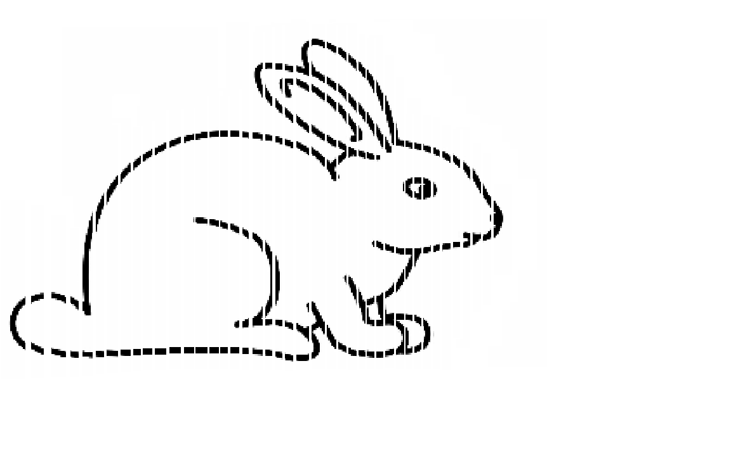
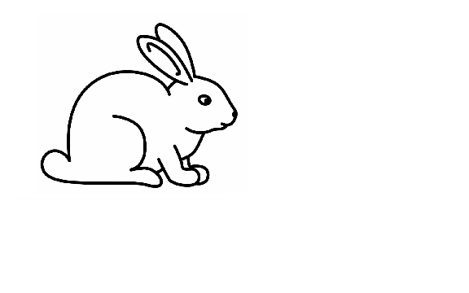
Slicer
Software

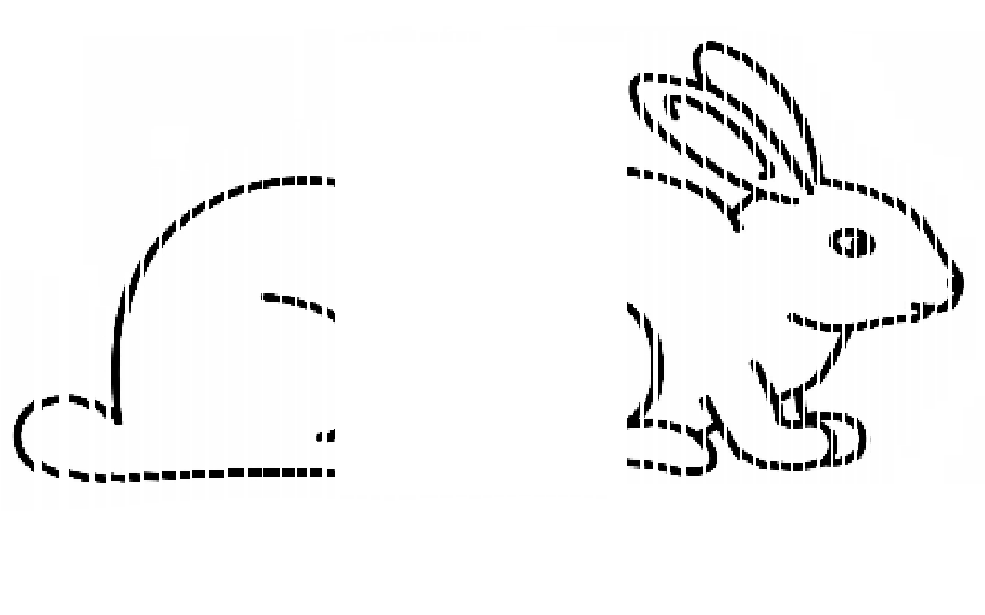
The Sliced 3D object is now a group of 2D images. These images will now be loaded onto the projectors. The machine operator can now chose from the group of images how many to transfer into each projector (A and B).

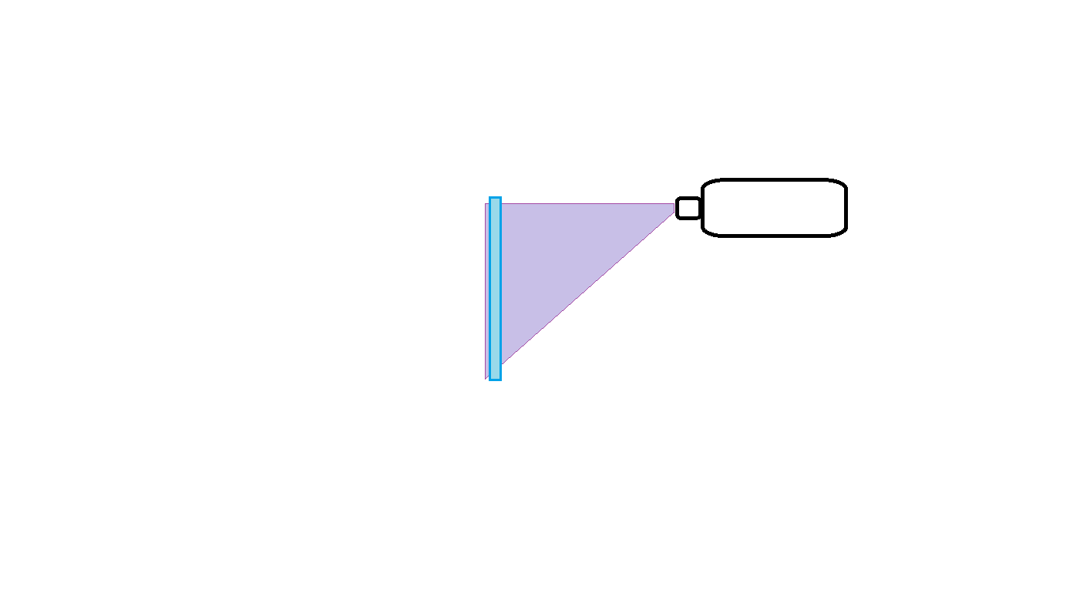
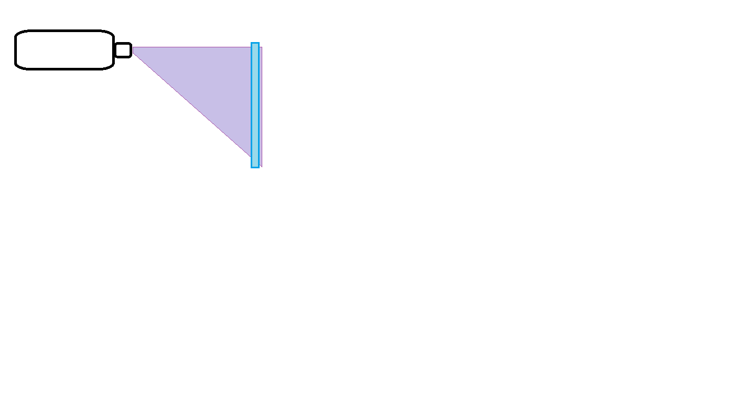
A
B
At this point everything is ready to start printing. The substrate plates will be positioned 1in apart for the resin to enter the tank in between these two plates.

Resin



A
B

Substrate plate A
Substrate plate B



They will then close in until they are 200um apart for the first layer to be printed.
B
A



The next few steps are very important. Once we reach the set up above projector B will turn ON for a certain amount of seconds (to be decided by the operator according to the resin type). That will print the 1st layer. Then Projector B turns OFF and Substrate plate A along with Projector A moves back 200um (or whatever layer thickness was decided by the operator).
A
Substrate plate A
moves back
B







The second layer is now going to be printed by Projector A. Projector A turns ON, prints, and turns OFF. The 2nd layer is printed. Meanwhile Projector B is still off, only Projector A is printing.
B
A
Now Projector A is going to print again (Projector B is still off). Projector A will keep printing alone until a certain thickness (a group of printed layers) is achieved in order to support the object being printed.





Now Substrate plate A moves back 200um again in order to print the 3rd layer. Prjector A turns ON, prints, turns OFF.


A
B








After projector A has printed enough layers so that the object is fixed on the walls and bottom of the tank, Projector B will start printing at the same time as projector A.
A
B

After the all the layers are printed our result is a 3D object.





At this point our 3D object is swimming in a tank full of resin. In order to rescue the object the resin must be removed from the tank with a pump. Once the tank is emptied the object can be removed and the substrate plates will close in again to their initial position.

Software

The Software must be able to follow the process explained above. In addition there are a few criteria the it must also meet.

- The time of exposure must be adjustable
  - Time of exporuse is the time that the UV projector stays ON in order to print one layer.

- The resolution must be adjustable.
  - Resolution is the thickness of each layer to be printed. That means how much the substrate plate will move back before each print.

- The offset feature
  - It allows the operator to place the first print offset from the middle of the tank towards the side of projector B. Offset distance needs to be adjustable.



Middle of the tank

A
B
Offset distance

- The Manual mode
  - It allows the operator to move substrate plates A or B manualy in desired direction and position.

- Safety
  - After the printing of an object is done a safety box must be checked saying that the part has been removed from the inside of the tank before the substrate plates are allowed to move again in any direction to any position.

